Inspection Certificate

Certificate No. | SUMICO-531-CA-900
Client Name | Power Cement Limited
Address | Nooriabad Industrial Area , Kalo Kohar , Distt Jamshoro , Sindh
Inspection Date | 15-10-2019
Inspection Due | 14-10-2020

Equipment Details

Equipment Name | Travelling Cranes
Tag I.D | FLS NO. 531-CA-900
Reference Standard /Code | BS 7121-2

Inspection Includes

- Thorough Examination
- Load Test
- Functional Test

Load Test

Load Test  ( Tonne ) | Safe Working Load  ( Tonne ) | Results
50.0 | 50.0 | Satisfactory

Inspected Item

Inspected item | Status | Inspected item | Status | Inspected item | Status
Controls & Operating Mechanisms | o.k. | Electrical Panel | o.k. | Runway Beam | o.k.
Lines , | o.k. | Hoist | o.k. | Pendant Conductor Track | o.k.
Hook Block |  | Pendant Festoon | o.k. | Bridge Girder | o.k.
Chains & End Connection | o.k. | Pendant Cable | o.k. | Bridge Idler Wheel | o.k.
Sling | o.k. | Wire Rope | o.k. | End Truck Bumper | o.k.
Trolley Drive | o.k. | Bridge Driver | o.k. | Trolley Frame | o.k.
Slings | o.k. | Bridge Driver Wheel | o.k. | Down Shop Conductor | o.k.
Sheaves & drums | o.k. | Runway Rail | o.k. | Pendant Switches | o.k.
Lifting Up & Down ( Smoothly ) | o.k. | Drive Control Forward & Reverse ( Smoothly ) | o.k. | Drive Control Left & Right ( Smoothly ) | o.k.

Note

o.k. | Condition satisfactory | M | Maintain
R | Replace | P | Provide

Digital Picture( s )

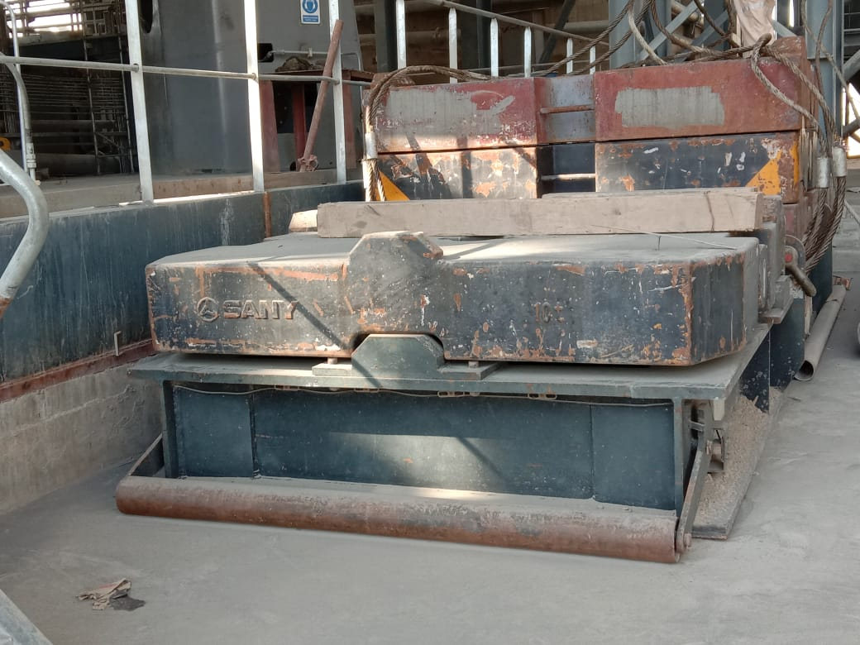 | 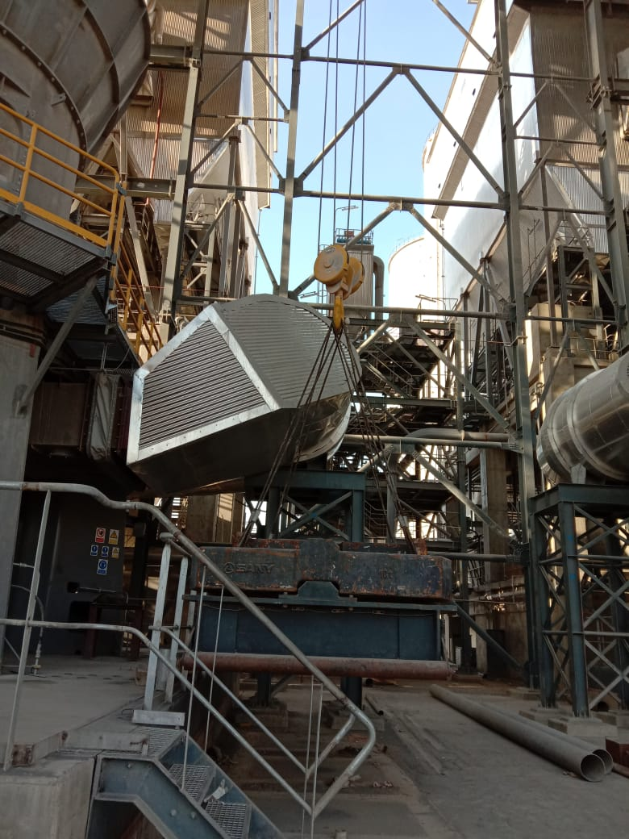
50.0 Tonne Weigh | Load Test
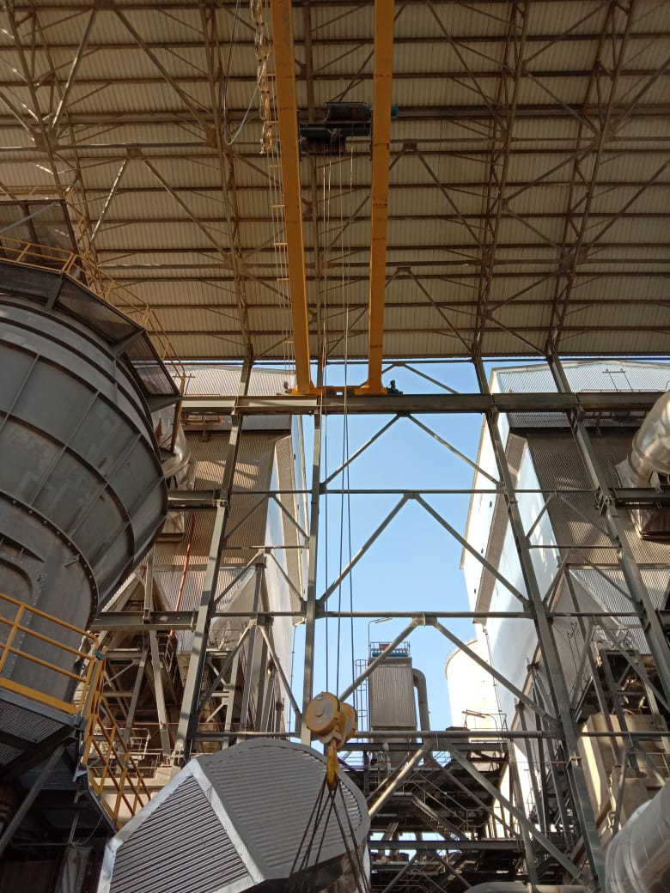 | 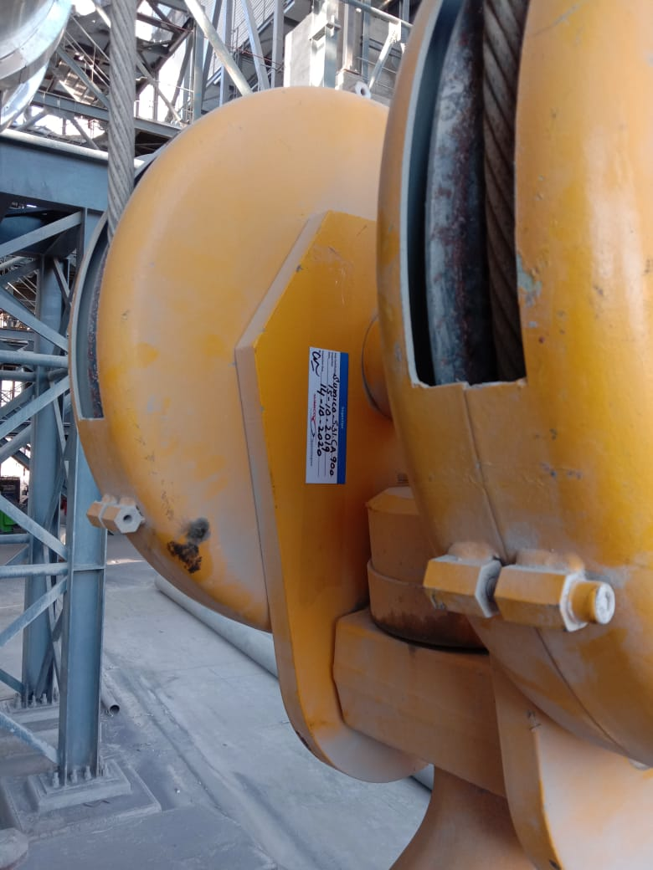
Travalling Crane | Inspection Sticker

It is certify That item(s) described above were examined in the prescribed manner. The inspection parameter’s mentioned.

Inspected by Approved by .

Engr. Zohaib Ikram Engr. Ikramul Haq

