IMMUSCO VISION/CALIBRATION SERVICES

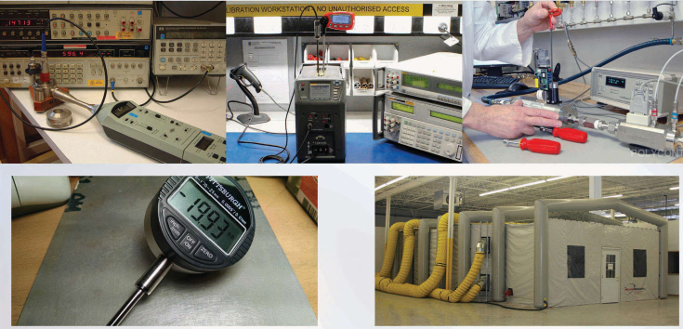
IMMUSCO is offering consultancy services to improve quality assurance and quality control of the product's through calibration, standardization, testing , process validation and evaluation of engineering products.IMMUSCO also possesses the capability to help steel industries in selection and service's of quality control tools and equipments i.e Emission spectro meter , tensile testing machine , bending machine , hardness tester and impact tester , temperature gauge , pressure gauge , gauge block , balances and host of other testing and measuring tools.

Our services are not limited only to provide calibration , material testing and evaluations service's but we offer technical assistance in handling shop floor problems by providing rectified measures to ensure continues and smooth operation/production of the mill's/plant.

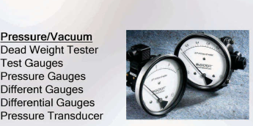
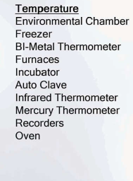

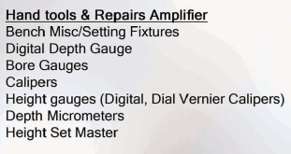

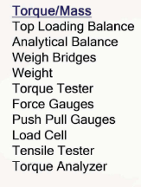

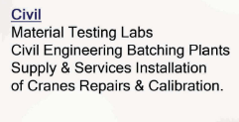
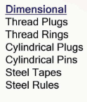

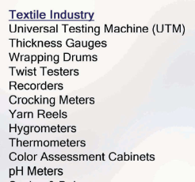

Area of the Potential Services
Petrochemical Industries.
Steel Rolling Mill's
Heavy Foundries
Boiler ,Bower's and Tanker Manufacture

IMMUSCO
CALIBRATION SERVICES

