"Optimize your plant maintenance activities via implementing state of the art Condition monitoring techniques with IMMUSCO"

• ■ •
■
• ■
■ • •
I
IMMUE

Industrial stability is driven by the enhanced machinery availability to meet the production targets. IMMUSCO experts help in analyzing the equipment health while in operation to understand and plan the maintenance procedures accordingly. Condition monitoring goes one step ahead in ensuring equipment reliability by timely diagnosing the troublesome machinery for its critical parameters.
CONDITION MONITORING MONITORING
Condition Monitoring Techniques
IMMUSCO provides complete plant integrity assessment solution via implementing following technologies:

Vibration Analysis
Over the years vibration monitoring and trending has evolved as a prominent source of condition monitoring and fault diagnosis. Every rotating and reciprocating machinery is studied for its baseline acceptable vibration limits upon commissioning and then trended over standard deviations measured in a scheduled vibration data acquisition and monitoring. Plant maintenance activities shift from preventive to proactive by timely addressing the vibration diagnostics, and thus enabling a reliable operation.
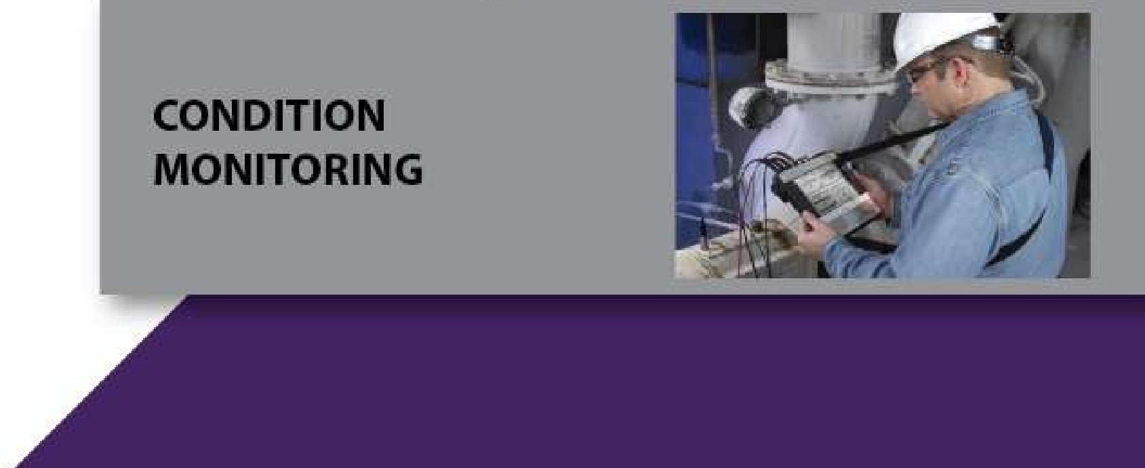
CONDITION MONITORING

0 161/i-1 Block M.A Johar 042-35951774
^{v} Town Lahore
grdi support@immusco.com ei) www.immusco.com

